**UDP Broadcast of DX Spots**

# Don Beaudry K1DBO, Lou Dietrich N2TU and Aki Yoshida JA1NLX

## 1. 0 GENERAL

Logger32 can relay DX Spots and Local Spots using the N1MM logger+ protocol. DX Spots, as displayed in the Logger32 DX Spot Window, are broadcast via UDP. The default port is 12061. If your configuration has a port conflict with 12061, you can edit the Logger32.INI and change the default setting in the [Globals] section

**[Globals]**

**DX Spot UDP Port=12061**

DX Spots are readily available to anyone from many sources, DX Clusters, aggregators, reverse beacons, etc. Once these DX Spots are fed into Logger32, and filtered as required by the user, they are then matched with the user’s logbook. New Countries, new Bands, new Modes, new Band/Modes are now associated with the DX Spots. Logger32 then displays the DX Spots with colored backgrounds and text that the user has chosen to uniquely identify information about the DX Spot. Additionally, information is attached to the DX Spot that identifies the Country, distance, beam heading of the DX Spot. This is the information that is included in the DX Spot broadcast message.

But why bother? The logging program knows, and displays, everything there is to know about the DX Spots. Software plays an increasing role in Ham Radio. More and more applications show spectrum displays, waterfalls and all kinds of eye candy. Today the operator’s eyes tend to focus more on the spectrum displays and not on the DX Spot windows of the logging programs. So, why not put the DX Spots on the spectrum, sort of like a ‘Heads Up Display’?

**Note:**

a. Currently UDP broadcast of DX spots can be used only with Flex Radio.

b. The details of N1MM logger+ protocol is explained in paragraph 4 "N1MM logger+ protocol"

## 2.0 SETUP IN LOGGER32

The DX Spot broadcast feature is enabled/disabled with a right click on the DX Spot Window then check/uncheck the Enable UDP broadcast of DX Spots menu.

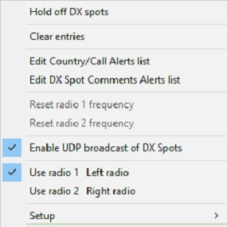

UBDS_1

## 3.0 HOW TO USE UDP BROADCAST OF DX SPOTS

Here are examples of how the UDP broadcast of DX Spots can be used with a Flex Radio to improve the users experience.

Flex Radio has a software module SSDR CAT. Connect SSDR CAT to Logger32 like this:

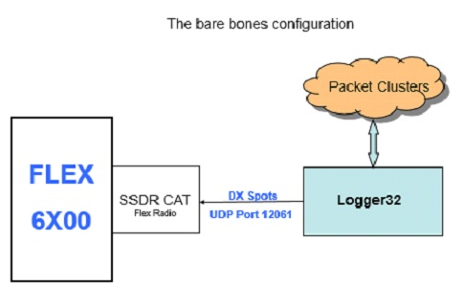

UBDS_2

Note: The details to setup SSDR CAT is explained in paragraph 5 “How to create the SSDR CAT Flex Radio UDP Port”

DX Spots will now be shown on the Flex Radio like this:

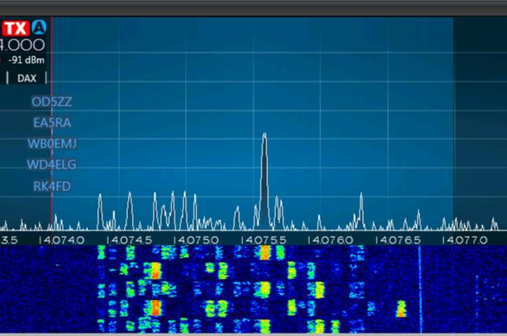

UBDS_3

All the DX Spots will have blue text, will not be shown in any form of priority (example: Need for new country first, need for WPX last), and will have no ToolTips with any additional information.

Results can be improved with a configuration like this:

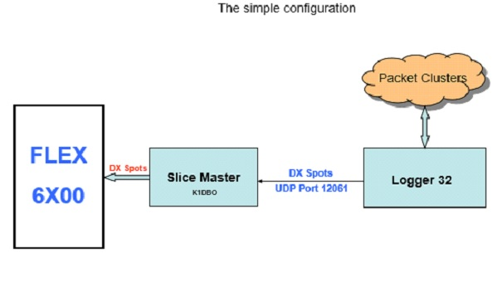

UBDS_4

**Note**:

a. Slice Master 6000 can be downloaded at https://github.com/K1DBO/slice-master-6000

b. Slice Master 6000 can be configured to send the Logger32 DX Spots to the Flex Radio with these settings:

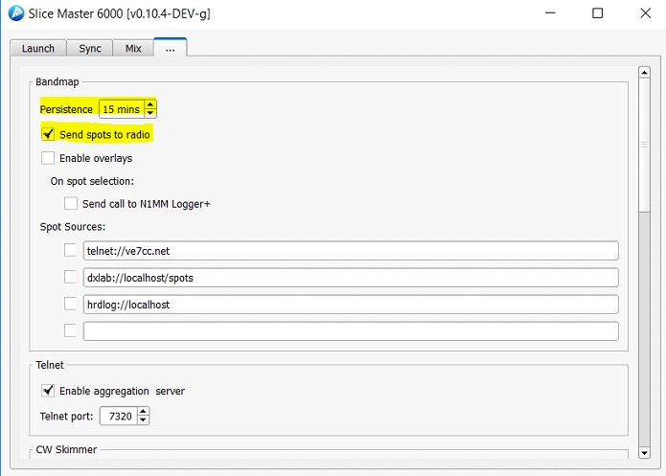

UBDS_5

This improves the DX Spots shown on the Flex Radio spectrum. DX Spots now have colored text. The text color is the same as the Logger32 DX Spots background color. DX Spots will be prioritized. A New Country DXSpot will be shown in preference to one of lower importance. Here is a sample of what the user will see:

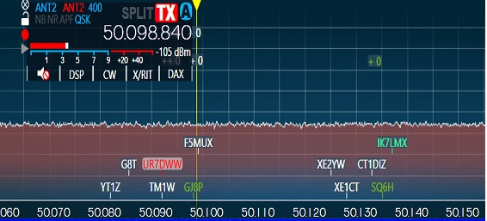

UBDS_6

In this example, Logger32 is configured so that New Countries have a red background. As you can see, UR7DWW is a new Country.

Slice Master 6000 can be configured to create its own DX Spots and overlay them on top of the Flex Radio pop-up windows. Slice Master 6000 configuration is like this:

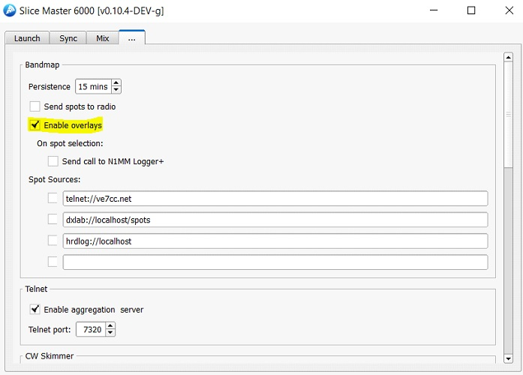

UBDS_7

The result is DX Spots with background and text colors that match the Logger32 DX Spot Window. ToolTip showing additional information can be seen. DX Spots are prioritized with most wanted/need first. Like this:

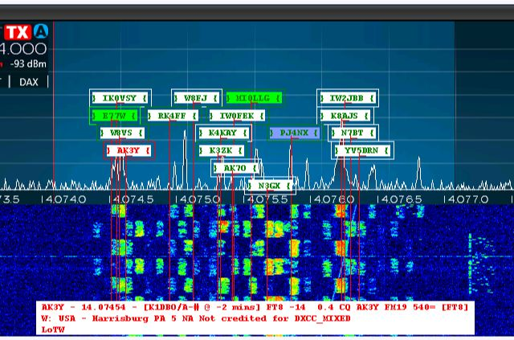

UBDS_8

For the very brave, and those with an addiction to DX Spots, a more complex configuration could be implemented:

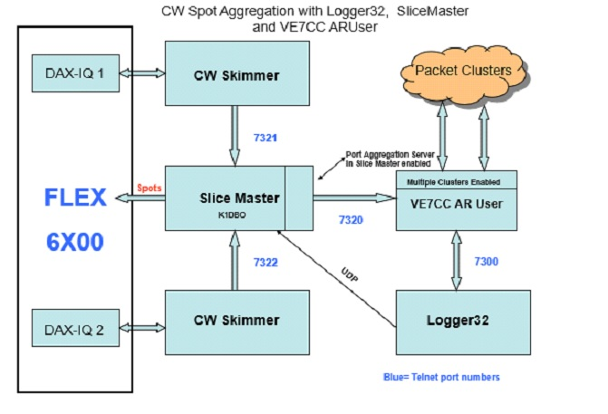

UBDS_9

## 4.0 N1MM LOGGER+ PROTOCOL

The N1MM logger+ protocol has been enhanced to include information added by Logger32, such as DX Spot priority, color, heading, distance and needed status.

The XML message structure is like this ~~(red text is Logger32 specific)~~

~~<?xml version="1.0" encoding="utf-8"?>~~

~~<spot>~~

~~<StationName>K4CY</StationName>~~

~~<dxcall>UN7NFD</dxcall>~~

~~<frequency>14017.4</frequency>~~

~~<spottercall>R0BB-#</spottercall>~~

~~<comment>CW 4 DB 19 WPM CQ </comment>~~

~~<action>add</action> ' add or delete~~

~~<status>new qso</status>~~

~~<logger32>~~

~~<source>Localhost</source>~~

~~<color>#FF0000</color> ' #RRGGBB~~

~~<needed_reason>Need on 20M CW</needed_reason>~~

~~<dx_spot_priority>3</dx_spot_priority>~~

~~<background>#FF9F80</background> ' #RRGGBB~~

~~<country prefix="UN" name="Kazakhsten" zone="17" continent="AS" heading="15" distance="10248Km"/>~~

~~<qsl_method>LoTW, OQRS</qsl_method>~~

~~</logger32>~~

~~<timestamp>2016-07-21 14:20:46</timestamp>~~

~~</spot>~~

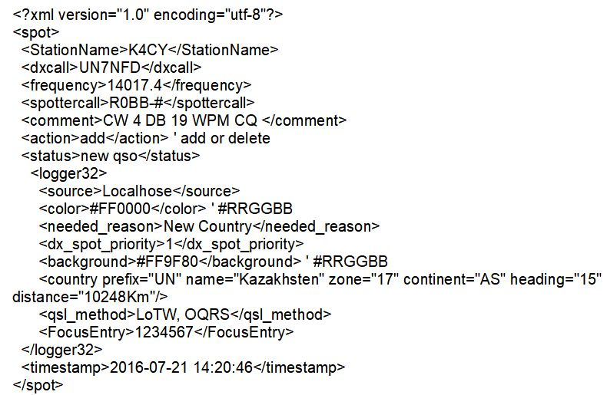

UBDS_10

**5.0 How to create the SSDR CAT Flex Radio UDP Port**

Open the SmartSDR CAT interface for the the FlexRadio Systems Signature Series radios.

Example:

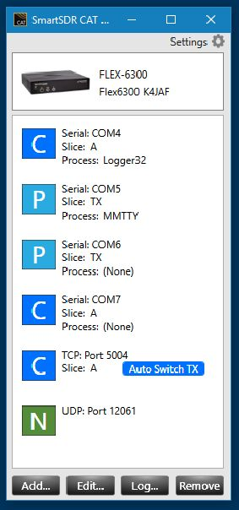

UBDS_11

Click on ADD Port. Change Port Protocol to N1MMSpot. Change UDP Port number to 12061 if necessary. Save the Port.

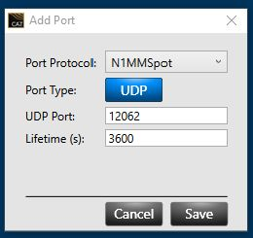

UBDS_12